**Model Development Phase Template**

|  |  |
| --- | --- |
| Date | 28 June 2024 |
| Team ID | 739860 |
| Project Title | A Comprehensive Measure of Well-Being:The  Human Development Index Using Machine Learning |
| Maximum Marks | 4 Marks |

**Initial Model Training Code, Model Validation and Evaluation Report**

The initial model training code will be showcased in the future through a screenshot. The model validation and evaluation report will include classification reports, accuracy, and confusion matrices for multiple models, presented through respective screenshots.

**Initial Model Training Code:**

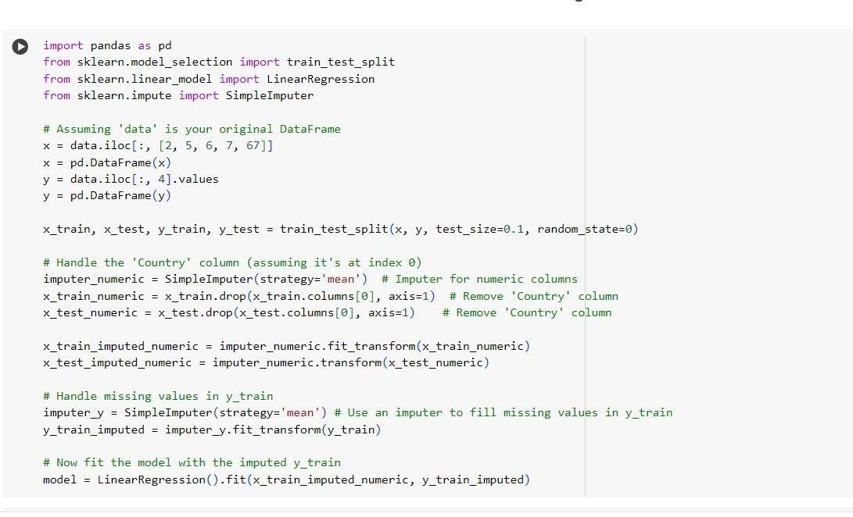

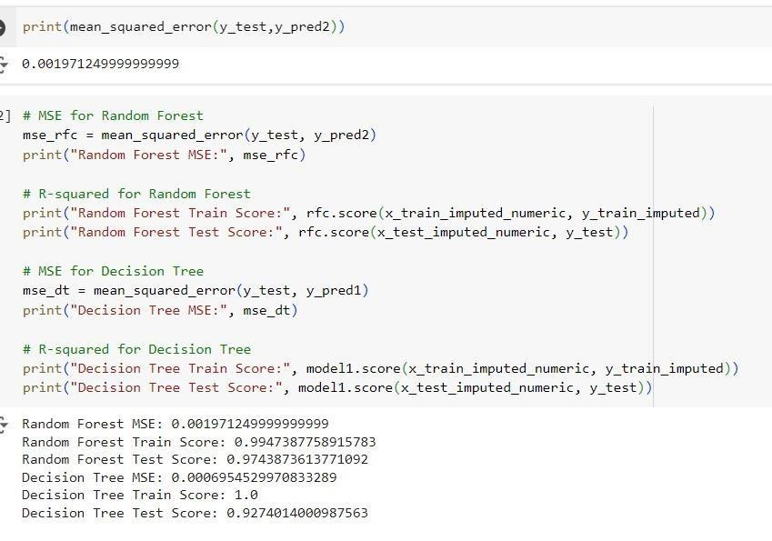

**Model Validation and Evaluation Report:**

|  |  |  |  |
| --- | --- | --- | --- |
| **Model** | **Classification Report** | **Mean Square Error** | **Accuracy Score** |
| Random  Forest |  | 0.0006954529970833289 | **Train:**0.9947387758915783  **Test:**0.9743873613771092 |

|  |  |  |  |
| --- | --- | --- | --- |
| Decision  Tree |  | 0.0006954529970833289 | **Train:**1.0  **Test:**0.9274014000987563 |

|  |  |  |  |
| --- | --- | --- | --- |
| Linear  Regression |  | 0.0007921136930643151 | **Train:**0.9534809529305541  **Test:**0.9708274723758666 |
|  |  |  |  |